**SQL Exercise 3**

1. **Display all the Supplier names with the initial letter capital.**

mysql> select concat(upper(left(sname, 1)), lower(substring(sname, 2))) as

capitalized_sname

-> from supplier;

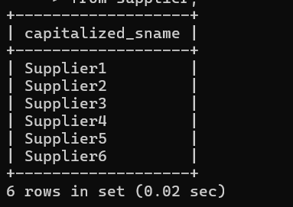

1. **Display all the Supplier names in upper case.**

mysql> select upper(sname) As uppercase_sname

-> from supplier;

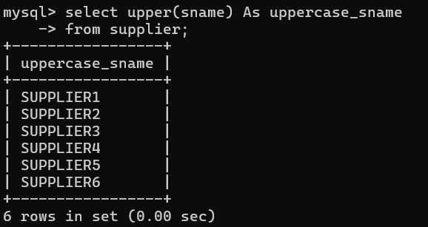

1. **Display all the Supplier names in lower case.**

mysql> select lower(sname) As lowercase_sname

-> from supplier;

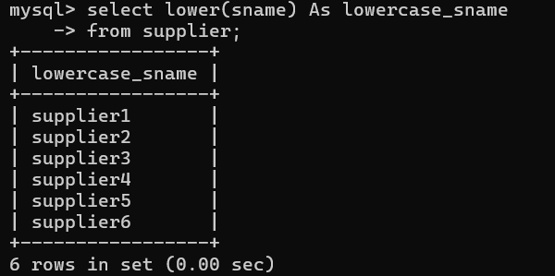

1. **Display all the Supplier names padded to 25 characters, with spaces on the left.**

mysql> select LPAD(sname, 25, ' ')As padded_sname

-> from supplier;

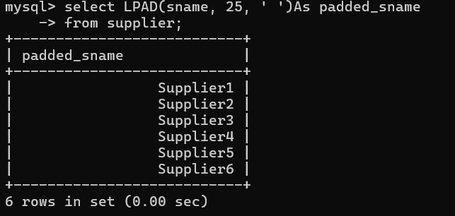

1. **Display all the Supplier names (with ‘li’ replaced by ‘ro’). HINT: REPLACE.**

mysql> select replace(sname, 'li' , 'ro')

-> from supplier;

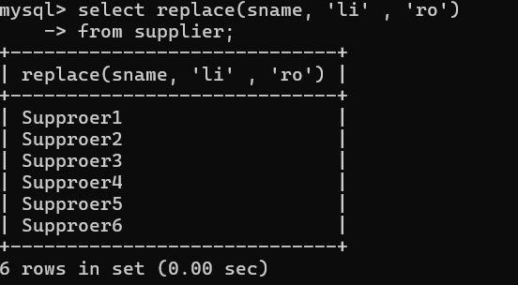

1. **Implement the above command such that ‘l’ is replaced with ‘r’ and ‘i’ is replaced with ‘o’.**

mysql> select replace(replace(sname, 'l' , 'r'),'i' , 'o')

-> from supplier;

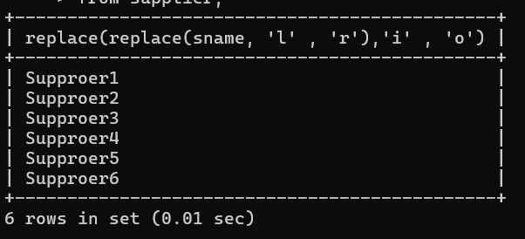

1. **Display the Supplier names and the lengths of the names.**

mysql> select sname, length(sname) As name_length

-> from supplier;

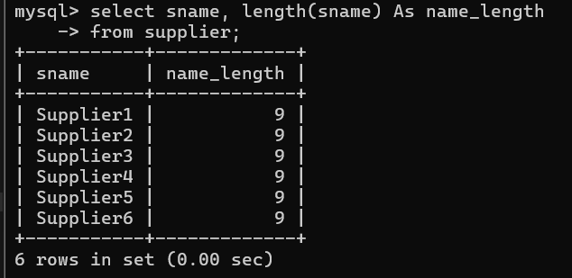

1. **Use the soundex function to search for a supplier by the name of ‘BLOKE’.**

mysql> select sname

-> from supplier

-> where soundex(sname) = soundex('bloke');

Empty set (0.01 sec)

The result indicates that no suppliers in above table have names that sound similar to "BLOKE" based on the SOUNDEX algorithm.

1. **Display the Supplier name and the status (as Ten, Twenty, Thirty, etc.).**

mysql> select sname,

-> case

-> when status = 10 then 'Ten'

-> when status = 20 then 'Twenty'

-> when status = 30 then 'Thirty'

-> when status = 40 then 'Forty'

-> else 'other'

-> end as status_in_words

-> from supplier;

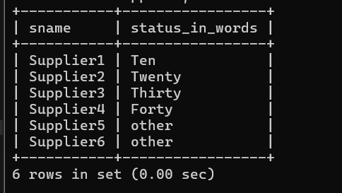

1. **Display the current day (e.g. Thursday).**

mysql> select dayname(curdate()) As current_day;

